WGAPE Spring 2013 Conference

Directions to Marriot Hotel and WGAPE Conference

The WGAPE Conference will be held in the Sloane School, Building E62, Room 221. As you enter Sloane E62 from the river entrance (see map below), you arrive at the Sloane cafeteria and social space. Room 221 is located immediately above the cafeteria. Go left upon entry, and take the first stairway on the right.

The Marriot Hotel in Boston is located at 2 Cambridge Center, Cambridge, MA 02142. Both the Marriot Hotel in Cambridge and the WGAPE Conference facility is located in, or very near to, Kendall Square. See map below. For a larger map of MIT, visit http://whereis.mit.edu/print.html

From Logan Airport

By taxi - Taxi fare from the airport is about $35–$40. During non-rush hour, the taxi ride will take about 15 minutes. During rush hour, the ride could take 30 minutes or more. Direct your drive to go to “Kendall Square”.

By subway - From any terminal at Logan Airport, take the Silver Line bus to South Station. At South Station, change to the Red Line subway to Kendall/MIT (towards “Alewife”). Under normal conditions the ride will take about one-half hour and the fare is $2.00 (Charlie Card) or $2.50 (cash). For schedules, visit http://www.mbta.com/.

From South Station

By subway - Take the Red Line subway (towards “Alewife”; Route information) three stops to the Kendall/MIT Station.

By taxi - Taxi fare from the airport is about $35–$40. During non-rush hour, the taxi ride will take about 15 minutes. During rush hour, the ride could take 30 minutes or more. Direct your drive to go to “Kendall Square”. See Map below.

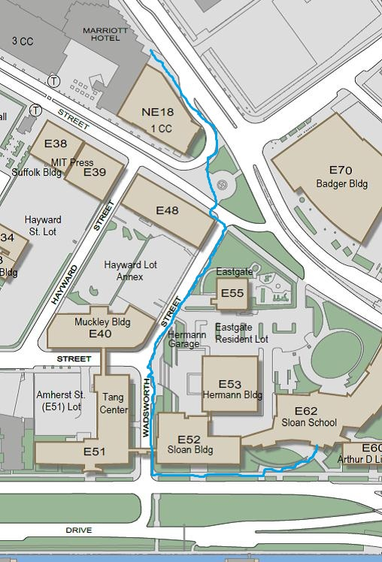
KENDALL SQUARE SUBWAY-STOP
WGAPE! RM 221

MARRIOT

